10 Year Landing gear inspection
AVEX Guide
Version 1.2 7/8/2021 (in progress)
- Notes and preparation
NOTE 1: During the 10-year “long life” landing gear check, you will also comply with: 1, 5, 10-year dimensional checks, strut inflation pressure checks, and lubrication of the gear. The 10-year long life inspection is an optional check that does not have an official checklist. There is Daher guidance in the form of a powerpoint that the mechanic performing the check should also reference. This guide is for reference only.

NOTE 2: The only appreciable differences between the old and new MLG assy’s are the tires and wheels they use, and the strut inflation pressures. Also, the old style gears have safety and squat switches with detachable cannon plugs.

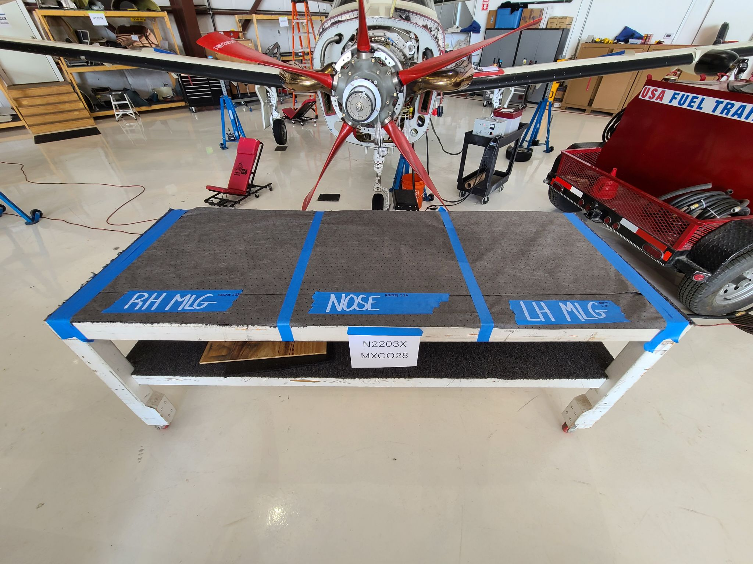
  - Prepare a table with absorbent mat and divide the workspace into three sections with tape.
  - Label the sections of the table into LH MLG, Nose Gear, and LH MLG. This will help keep parts from the landing gear from becoming intermixed.
  - Attach a sign to the table with the N-Number and work order number of the inspection.
  - Find the P/N of the gear you are using and then make sure you are using the correct landing gear CMM. There is an old style and a new style.
  - Record P/N and S/N on half-sheet.

- Removal
  - Take note of the dimension of the safety and squat switches with a caliper. Measure the dimension and take a photo for reference during reassembly. **If landing gear position switches can be disconnected with a cannon plug then it is not necessary to measure/photograph or remove the switch.
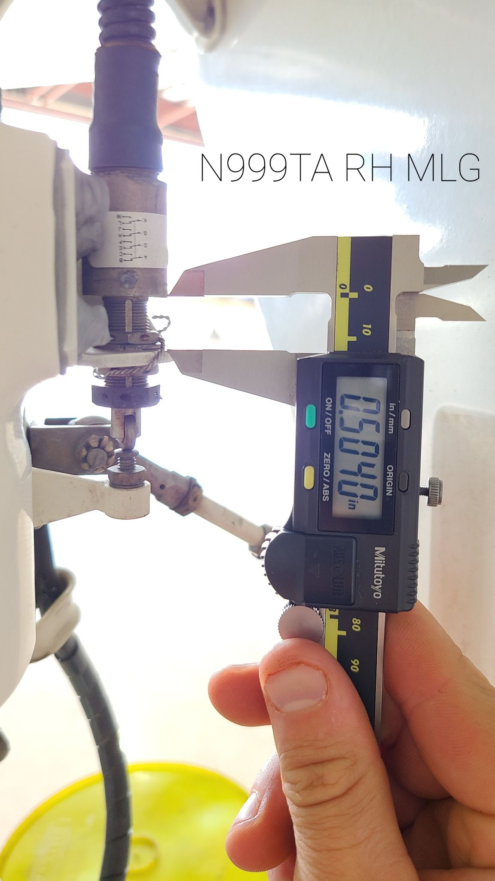
  - Jack aircraft.
  - Unlock/break landing gear so it is no longer locked in the down position.
  - Remove valve core and depressurize the wheels.
  - Remove wheels and label.
  - Remove brakes from landing gear but do not open brake line. Sit on a bucket or stool next to the MLG. This avoids having to bleed the brakes at the end of the inspection.
  - (INSERT NOSE GEAR REMOVAL HERE)
  - Take photos of the gear from different angles and save for later to refer to during assembly.
  - Release nitrogen charge from bottom high pressure fitting while holding a plastic bag up to the fittings outlet. Observe how much hydraulic fluid accumulates in the bag. If excessive (more than 1ml), the landing gear must be sent out for overhaul due to failure of the center piston seal. If less than 1ml continue with inspection. (INSERT PHOTO OF HYDRAULIC AND NITROGEN FITTINGS)
  - Remove landing gear door hardware and tie doors out of the way with string.
  - Clean sealant off of landing gear hardwear and pin locks.
  - Remove locking pins.
  - Hold the weight of the landing gear and have a second person pull out the FWD and AFT main gear pins.
  - Remove landing gear.
  - Place landing gear on table and purge hydraulic fluid from top high pressure fitting into a waste bucket using the landing gear hydraulic servicing tool. (INSERT IMAGE)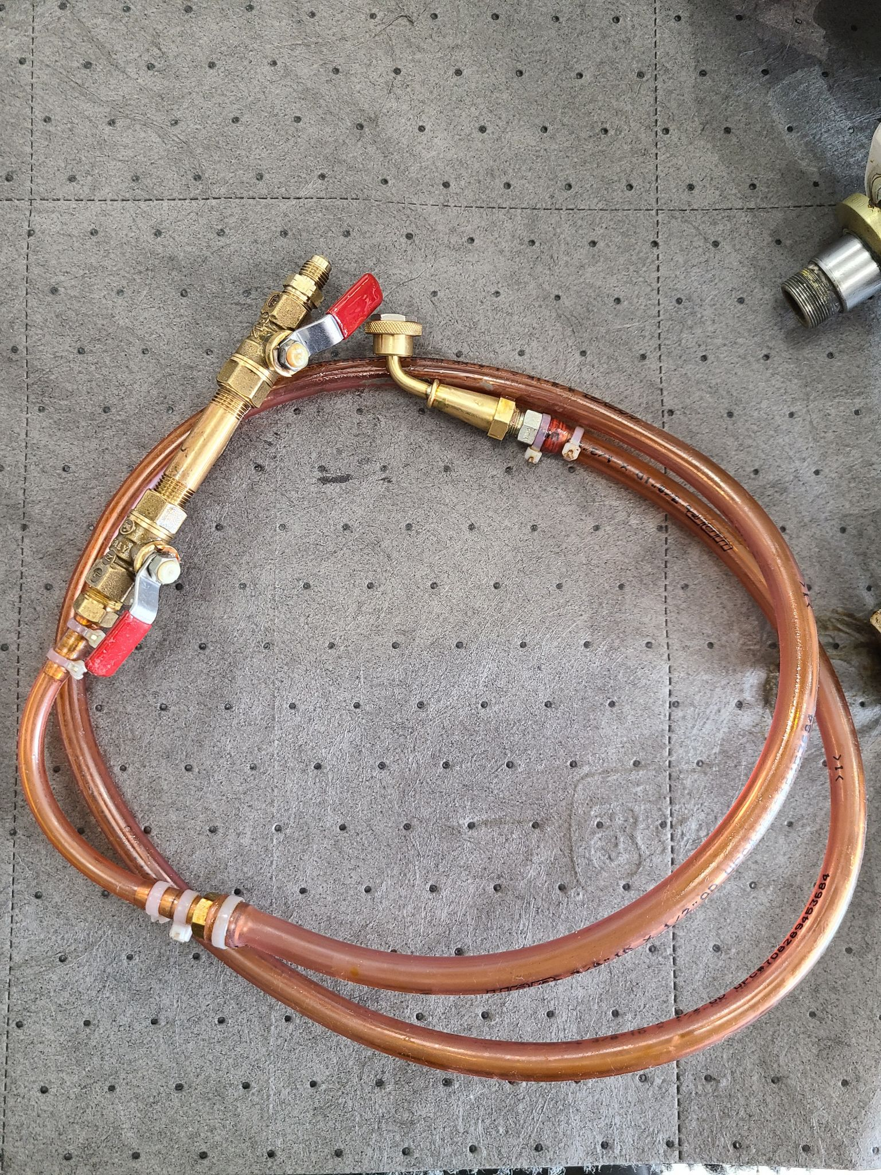
  - Take photos of gear for re-assembly reference.
  - Remove torque link assy.
  - Remove bottom nitrogen servicing valve assy.
  - Remove bottom piston retainer and bottom piston plug with special tool (or a brass punch of the correct size and a wrench, using both as a improvised puller tool). The nose gear has the same set up but with a different size piston and requires a different size brass punch.
  - Separate valve core from schrader valve on bench to avoid breaking off on gear assy.
  - Remove top and bottom schrader valve assemblies.

- Inspection
  - Clean landing gear and all landing gear bores.
  - Clean landing gear components for visual and dimensional inspection, including hardware. Remove grease from inside of mated pins.
  - Perform visual inspection, mainly for corrosion but also any other defects on the entirety of the landing gear.
  - Remove bolt retaining axle for visual inspection and borescope inspection.
  - Borescope all bores and perform visual inspection.
  - Visually inspect all removed components and hardware.
  - Perform 10-year dimensional check of landing gear.
    - See the highlighted dimensional check sheet at the end of this document.
      - Perform torque link dimensional check with bench tool.
- Coating loss is not cause for rejection of pistons or pins, or bolts unless the coating loss is associated with corrosion, or deformation or cracks.
  - Do not apply Alodine to non aluminum parts.

- Reassembly
  - Replace o-rings nitrogen (2x) and 5606 schrader valves.
  - Replace piston o-ring and wiper rings . It is critical to have a second person look over the installation, as this wiper ring is easily cut.
    - Apply DX paste (or mastinox) to bottom of piston and 5606 to o-rings.
    - Apply 5606 to inside of piston bore.
    - Carefully insert the piston into the bore, minding the o-ring and split washers. Make sure that o-rings and washers are not damaged during installations by observing them through the bolt and survive holes.
  - Apply DX paste to piston insert, and align small piston insert into piston with holes aligned for the drilled pin.
  - Apply DX paste to drilled pin, pre-aligning the center bolt holes to accept a pin when installed.
  - Insert drilled pin.
  - With it inserted, you should have the center holes aligned enough to see through the pin to the back of the piston insert. Use tapered punches to align all the center components.
  - Install the drilled pin insert if not already installed into the drilled pin.
  - Install bolt with new locking tab at bottom of the piston. VERIFY THIS IS CORRECT
  - With two new o-rings, install the bottom piston nitrogen schrader valve.
  - Assemble torque link with correct washer stack up and clearances. Ensure there is one washer between the torque link bushings, and choose the size of that washer by using the bench check tool to determine the appropriate size.
    - There is currently no known exact dimension that should be attained, but excessive play should be avoided when assembling the torque link. There are various size washers you can order to accomplish minimal play between installed torque link halves if necessary.
    - Using the original hardware, measure the center gap between the two torque link halves and choose the washer that most closely fills the center gap.
    - REF CMM 32-11-01 Pg 705 (E).
    - (INSERT PHOTO OF TORQUE LINK CHECKING TOOL AND MEASUREMENTS)

  - Install the gear with its main pins
  - Connect to landing gear actuators.
  - Follow CMM for installation.
  - Put on lock washers nuts but do not lock them.
  - After installation, service the gear with hydraulic fluid (5606) and Nitrogen.
    - Servicing of the hydraulic fluid should follow the manual. Fill top chamber completely with fluid and then compress to expel air. Compress and fill the strut multiple times until there is no air left in the return line.
    - Finish the gear by compressing it full of fluid until there is a 0.606” gap of chrome showing the same heights as the brake bleeding adapter when turned sideways.
      - This is an Avex way of filling the stut and maintains more fluid in the strut. If the nitrogen charge is ZERO the strut will have a little bit of fluid to ride on. This is Avex’s way of doing the gear, and is not approved by the manufacturer.
    - Service bottom port of MLG assy with nitrogen, verifying the correct pressure for the assembly by looking at the placard installed on the MLG. (Apply nitrogen pressure for 10 minutes and ensure the pressure remains the same; if not, look for leaks and reservice.)
  - Fill with nitrogen IAW with the manual: 160 PSI.
      - 165 PSI is Avex’s summer setting.
      - 170-175 PSI is Avex’s winter setting.
    - Check for fluid and pressure leaks.
    - After you have verified that the gear assembly is not leaking fluid or pressure, torque and lock both main pins and actuator attachment.
  - Install the brake line and adjust to prevent chafing on landing gear well when retracting gear.
  - Secure electrical harnesses and connectors with zip ties. Provide enough slack so extension and retraction does not break the wires.
    - On old style landing Verify the routing of the
  - Attach safety switch.
  - Lubricate the main gear pins with Aeroshell 22.
  - Keep landing gear doors unattached for inspection of gear during retract test.
  - Install wheel assemblies.
  - Service landing gear hydraulic fluid reservoir.
  - Clear the gear of tools and people.
  - Perform gear swing test, ensure tires rotate freely when retracted, and check distances between wheel well and tire.
    - Verify that the NLG and MLG Doors are flush.
    - If doors are not flush, adjust for correct fit.
    - Verify that the brake lines are not contacting the airframe when the gear is in motion. If needed, adjust the brake lines to provide clearance from the airframe and secure the line with zip ties near the upper adel clamp.
    - Install landing gear doors, and perform another swing test and emergency extension test.
    - Operationally test the Taxi light if installed on the NLG.
  - Seal the landing gear hardwear with pro seal B1/2. Reference photos of original gear so you don't miss any sealant areas.
  - (insert photo of areas to seal MLG and NLG)
  - Verify that there are three green landing gear indications before you lower the aircraft. Lower the aircraft slowly onto the ground and carefully observe all the main struts. If struts are improperly serviced, they will either be far too high or far too low.
  - Check the NLG steering stop for correct paint.
  - If the gear is supporting that aircraft correctly then remove all tools, clean up your work area including the table used for landing gear inspections, and finish your paperwork.

MAIN GEAR FITS AND CLEARANCES
FOR 10 YEAR LONG LIFE INSPECTION
N# _________ WO_______________ RH____ or LH_____
Landing Gear Assy P/N__________________S/N________________

*In reference to Main landing Gear CMM for P/N D23767000, D23768000 CH 32-11-02 PG 801 Table 1 (fits and clearances), here are the measurements traditionally taken for the 10 year long life inspection program.
*Figures referenced in this form are found in the CMM IPC.
*For older style landing gear P/N 21135-001, P/N 21135-002, P/N 21136-001, P/N 21136-002, these tolerances are the same but the figure reference is different and should be disregarded. The reference for old style gear is CMM for P/N 21135-001, P/N 21135-002, P/N 21136-001, P/N 21136-002, Ch. 32-11-01.
MAIN GEAR FITS AND CLEARANCES
FOR 10 YEAR LONG LIFE INSPECTION
N# _________ WO_______________ RH____ or LH_____
Landing Gear Assy P/N__________________S/N________________
Red= Manual is unclear |  | Yellow= Not recorded in practice. | Note, original dimensions
Name | Current Dimension (MM) | Nominal Dimensions  (MM) | Min or Max after wear  (MM) | Pass?  (Y/N)
A (UNK) | N/A | 17 (+0.15; -.010) | 16.8 | N/A
B1 Center torque link bore (ID) |  | 12 (+0.024; +0.006) | 12.048
B2 Center torque link bore (ID) |  | 12 (+0.024; +0.006) | 12.048
C1 Torque link Bore (FIG 2 Item 050) (ID) |  | 16 (+0.024; +0.006) | 16.048
C2 Torque link Bore (FIG 2 Item 040) (ID) |  | 16 (+0.024; +0.006) | 16.048
C3 Torque link Bore (FIG 2 Item 120) (ID) |  | 16 (+0.024; +0.006) | 16.048
C4 Torque link Bore (FIG 2 Item 120) (ID) |  | 16 (+0.024; +0.006) | 16.048
D Outer dimension of torque link attach | N/A | 60 (+0.15; +0) | 60.3 | N/A
E Shouldered Axle Torque link center bolt. (FIG 2 Item 180) (OD) |  | 12 (+0.016; +0) | 11.984
F1 Torque Link Axle/Pins (FIG 2 Item 280) (OD) |  | 16 (+0.016 ; +0) | 15.984
F2 Torque Link Axle/Pins (FIG 2 Item 290) (OD) |  | 16 (+0.016 ; +0) | 15.984
G Main pin large (FIG 3 Item 050) (OD) |  | 31.75 (-0.025; -0.050) | 31.65
SEE NEXT PAGE
H Main pin small (FIG 3 Item 120) (OD) |  | 25.4 (-0.020; -0.041) | 25.318
I Actuator pin attach (FIG 3 Item 280) (OD) |  | 25.4 (-0.020; -0.041) | 25.318
J Center of bottom trunion (ID) |  | 61 (+0.046; +0) | 60.848
K Main Piston “Chrome” (Fig 1) (ID) |  | 69.8 (-0.030; -0.060) | 69.68
L Bottom retaining pin (FIG 5 Item 150) (ID) |  | 16 (+0.068; +0.050) | 16.136
M Bottom piston base (FIG 5 Item 070) (OD) |  | 60.9 (-0.030; -0.076) | 60.748
Torque Link play check on bench tool. | Center torque link gap | Center washer thickness
Manual dimensions | N/A
Recorded dimensions

NOSE GEAR FITS AND CLEARANCES
FOR 10 YEAR LONG LIFE INSPECTION
N# _____________ WO___________
P/N_________________ S/N________________
*In reference to Nose landing Gear CMM for P/N D23766000 CH 32-21-02 PG 801 Table 1 (fits and clearances) Here are the measurements traditionally taken for the 10 year long life inspection program.
*Figures referenced in this form are found in the CMM IPC.
*For older style landing gear P/N 21135-001, P/N 21135-002, P/N 21136-001, P/N 21136-002 these tolerances are the same but the figure reference is different and should be disregarded. The reference for old style gear is CMM for P/N 21135-001, P/N 21135-002, P/N 21136-001, P/N 21136-002 Ch. 32-11-01.
NOSE GEAR FITS AND CLEARANCES
FOR 10 YEAR LONG LIFE INSPECTION
N# ________________ WO_______________________
P/N_____________________ S/N___________________
Red= Manual is unclear |  | Yellow= Not recorded in practice. | Note, original dimensions
Name | Current Dimension (MM) | Nominal Dimensions  (MM) | Min or Max after wear  (MM) | Pass?  (Y/N)
A1 Torque link Bore (Item 110) (ID) |  | 16 (+0.024; +0.006) | 16.048
A2 Torque link Bore (Item 100) (ID) |  | 16 (+0.024; +0.006) | 16.048
A3 Torque link Bore (Item 140) (ID) |  | 16 (+0.024; +0.006) | 16.048
A4 Torque link Bore (Item 140) (ID) |  | 16 (+0.024; +0.006) | 16.048
B1 Center torque link bore (Item 150) (ID) |  | 12 (+0.024; +0.006) | 12.048
B2 Center torque link bore (ID) |  | 12 (+0.024; +0.006) | 12.048
C (UNK) | N/A | 17 (+0.15; -.010) | 16.8 | N/A
D Outer dimension of torque link attach | N/A | 60 (+0.15; +0) | 60.3 | N/A
E1 Torque Link Axle/Pins (Item 170) (OD) |  | 16 (+0.016 ; +0) | 15.984
E2 Torque Link Axle/Pins (Item 180) (OD) |  | 16 (+0.016 ; +0) | 15.984
F Shouldered Axle Torque link center bolt. (ID) |  | 12 (+0.016; +0) | 11.984
G1 Hinge Pin (Item 040) (OD) |  | 25 (-0.020; -0.041) | 24.918
G2 Hinge Pin (Item 140) (OD) |  | 25 (-0.020; -0.041) | 24.918
H Actuator attach point (Item 280) |  | 25.4 (-0.020; -0.041) | 25.318
SEE NEXT PAGE
I Bottom piston (item 240) (ID) |  | 43.2 (+0.039; +0) | 43.278
J Main Piston “Chrome” (OD) |  | 50.75 (-0.030; -0.060) | 50.63
K Locking Pin bottom (Item 340) (OD) |  | 12 (-0.050; -0.068) | 11.864
L Lower torque link bushing (Item 250) |  | 16 (+0.068; +0.050) | 16.136
M Bottom Piston Base (Item 380) (OD) |  | 43.1 (-0.025; -0.064 | 42.972
Torque Link play check on bench tool. | Center torque link gap | Center washer thickness
Manual dimensions | N/A
Recorded dimensions

